**Current Rate Structure**

**7.7.1 Income \*\*\***

Income to the District is derived from water service charges and ad valorem tax. A water rate was prepared by the District for the purpose of recommending new rates consistent with the present and future financial needs of the District. The rate schedule developed presented a four-year escalating rate plan, this being the first year of the plan. The financial goal of the District is to have a net revenue greater than or equal to the projected new debt service, a 10% debt service reserve, and a short-lived asset reserve. The District’s revenue schedule is shown in Table 12.

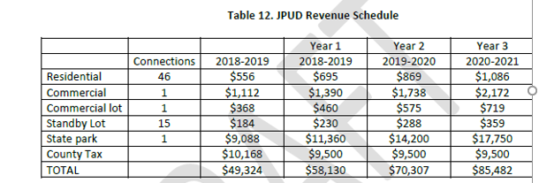

The District is seeking project funding from USDA Rural Development's Rural Utility Services Program. The District will need to reconsider the income and expenditures within its water fund along with the new debt service obligations required to repay any loan obtained. With a few exceptions, the major public works infrastructure funding programs expect an agency's monthly water bill to be at least 1.5 percent of MHI. USDA Rural Development has indicated they will utilize the MHI as determined by Census Tract 2.01. Block Group 1, which is $54,334. Using the 1.5 percent threshold for the MHI, the JPUD’s monthly water rate would need to be at least $67.92 per month per service before qualifying for grant funding. The JPUD’s current water residential rate (2019-2020) is $72.42 per month per service. Therefore, the monthly water rate complies for potential grant funding.

The goal for funding the recommended project will be to secure a long-term, low-interest loan with debt service obligations up to 1.5 percent of MHI. Then, attempt to acquire grant funding for the amount beyond the loan amount.

***DRAFT Johnsville Water Improvement Project JPUD19-001 41 Preliminary Engineering Report June 12, 2020